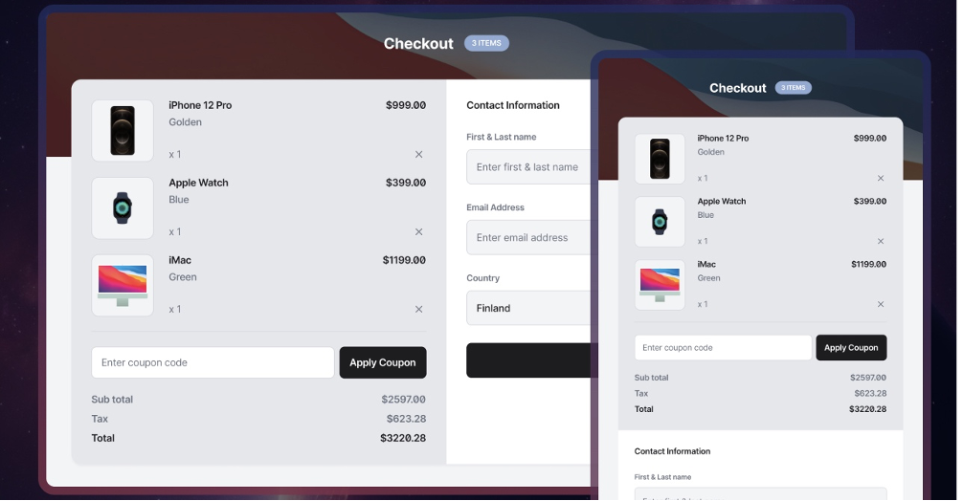

**Checkout Page Website design**

You are required to build a **Pride of Cows checkout page website** with the following elements:

1. **Summary Section**:  
List all the products offered, such as premium milk bottles, dairy products (paneer, curd, butter), and other add-ons like subscription packages.

2. **Contact Form Section**:  
Users need to provide their name, email, delivery address Section (Pin code, House No, Street Road) for checkout.

**Requirements**

You need to create a web page for the **Pride of Cows checkout page** that includes:

1. **Fundamental CSS Layout Techniques**:

o You can use **Flexbox** for product alignment and content layout.

o You can use **CSS Grid** for structuring the main sections.

2. **Summary Section**:

o Display a list of Pride of Cows products, including:

§ Premium milk bottles

§ Dairy products: paneer, butter, and curd.

§ Subscription packages: Weekly or Monthly plans.

§ Quantity Addition

o Include pricing and small product thumbnails for better visuals.

3. **Contact Form Section**:

o A form where customers can enter their details:

§ Name

§ Email

§ Delivery Address & other sections

o Style the form to be clean, user-friendly, and easy to navigate.

4. **Responsive Design**:

o Ensure the layout adapts to different screen sizes. (Desktop and Mobile view)

o Mobile-friendly design with touch-friendly form fields and grids.

5. **Visual Appeal**:

o Use **clean styling** that aligns as close as the shared image.

o Add subtle hover effects, clean buttons, and a structured layout.

o Make sure the **website loads quickly** and works on all devices.

**Deliverables**

* A fully functional **HTML, JS and CSS** page.
* Source code shared via **GitHub**, CodePen, or a zip file.

Bonus points:

Feel free to add cart functionality with counter when items are added or removed (Not mandatory but good to have)